REPORT

EVENT MANAGEMENT

SYSTEM:

C.S.E.326

TEAM:

* ABHAY PRATAP SINGH -11908655-39
* VIBHAV SINGH -11908698-40
* DILEEP PAL -11910534-41

TITLE OF THE PROJECT:

Event Management Sytem.

PROJECT OBJECTIVE:

This system helps the user to register for different kind of Events

.

PROJECT CATEGORY:

Website or Web Application.

INTRODUCTION:

Event Management System is a Web Application that allows the users to register for different kinds of events such as Sports Events, Conference, Cultural Events, etc. Users can give the information related to the event to be organized such as Event Starting Date, Event Ending Date, Number of people, etc.Event organisation, whether big or small , has chaleenges to overcome and managing the information of Activity, Event,Attendees , Payment,Conductors.Every Event Management system has a different Event needs,Therefore we design exclusive employee management systems that are adapted to your managerial requirements. This is designed to assist in strategic planning,and will help you ensure that your organisation is equipped with the right level of information and details for your future goals. Also,for those busy executive who are always on the go , our systems come with remote features, which will allow you to manage your workforce anytime , at all times. These systems will ultimately allow you to better manage resources.

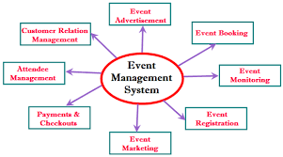

MODULE DESCRIPTION:

**Main webpage will have the following modules:**

***1.EVENT TYPE:***It will consist of options related to the type of event to be organised and let users to select one of the options that they aspire for the event.

This module includes tabs like:

1. **SPORTS.**
2. **CULTURAL.**
3. **CONVOCATIONAL.**
4. **CONFERENCE.**

***2.ORGANIZE:***This module or tab allows the user to fill the information related to the event to be registered.

Following tabs are included in this module:

* **FULL EVENT:**
* This tab will allow users to give information about the full event and procedures of the event.
* **FOOD:**
* This tab allows the users to select if they want fooding options during the event and also helps them choose the kind of food they would like to have.
* **TRANSPORT:**
* This tab allows the users to opt for transport services as per their needs. They will have to select the type and number of vehicles.
* **LODGING:**
* This tab allows the users to opt for lodging services like rooms and hotels as per their demand of number of rooms.

***3.EVENT STARTING DATE:***

* This module allows the users to enter the starting date of the event.

***4.EVENT ENDING DATE:***

* This module allows the usersto enter the ending date of the event.

***5.NUMBER OF GUESTS:***

* This module allows the users to give information about the number of guests going to attend the event.

***6.PAYMENTS:***

* This module allows the users to confirm the registerations done.

***7.ADD-ONS:***

* This modules allows the users to give information about the additional services to be opted as per the needs of the users.

***8.SPECIAL PACKAGE:***

* This module give users chance to opt for the special package that will give users some extra facilities without extra charges of add_ons .

***9.LOGIN:***

* This will allow users to login using their email and password.

They can register only after loging in to their accounts.

***10.CONTACT:***

* Information regarding the Event managers are given in this module, such as phone number, email address, Office address, etc.

***DFD ( DATA FLOW DIAGRAM ) of Event Management System***

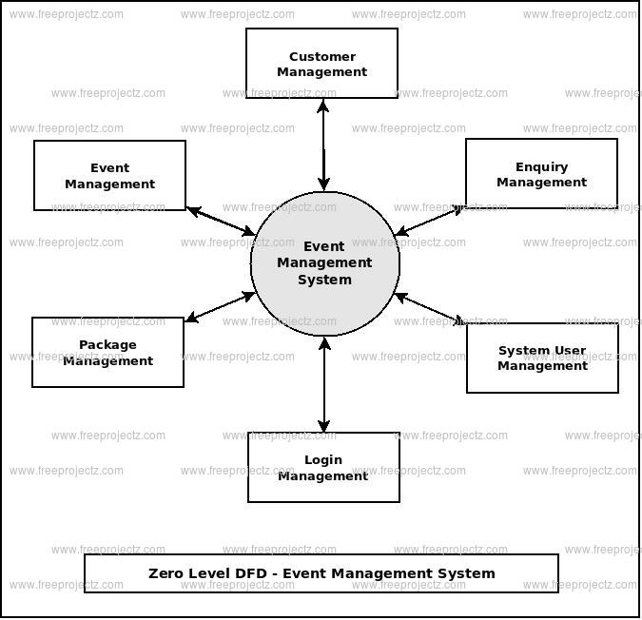

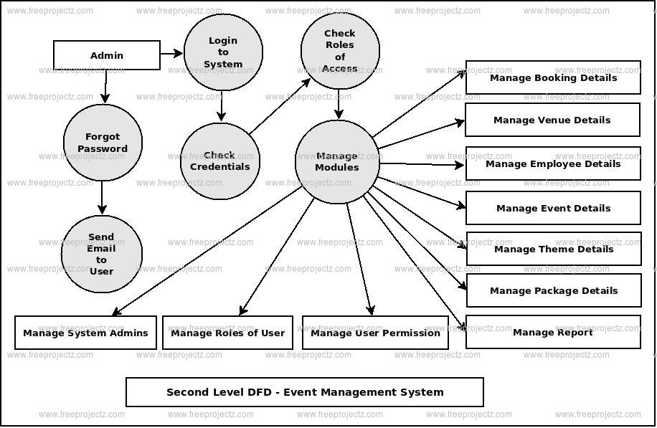



***ER-DIAGRAM:***

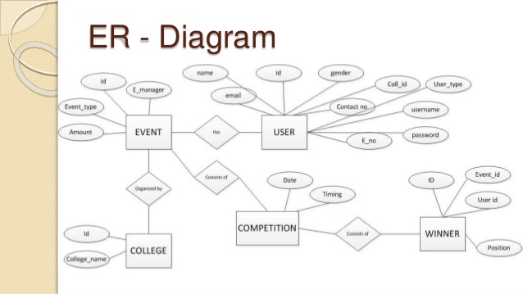

***SOME ADVANTAGES OF THIS SYSTEM:***

* This system provides the users with simplified way of selecting the type of event they want to host.
* Multiple options are provided to users to opt from. Thus, giving them variety.
* Users can even choose for lodging and transport services which makes things even easier for them.

***SCREENSHOTS OF WEBPAGE:***

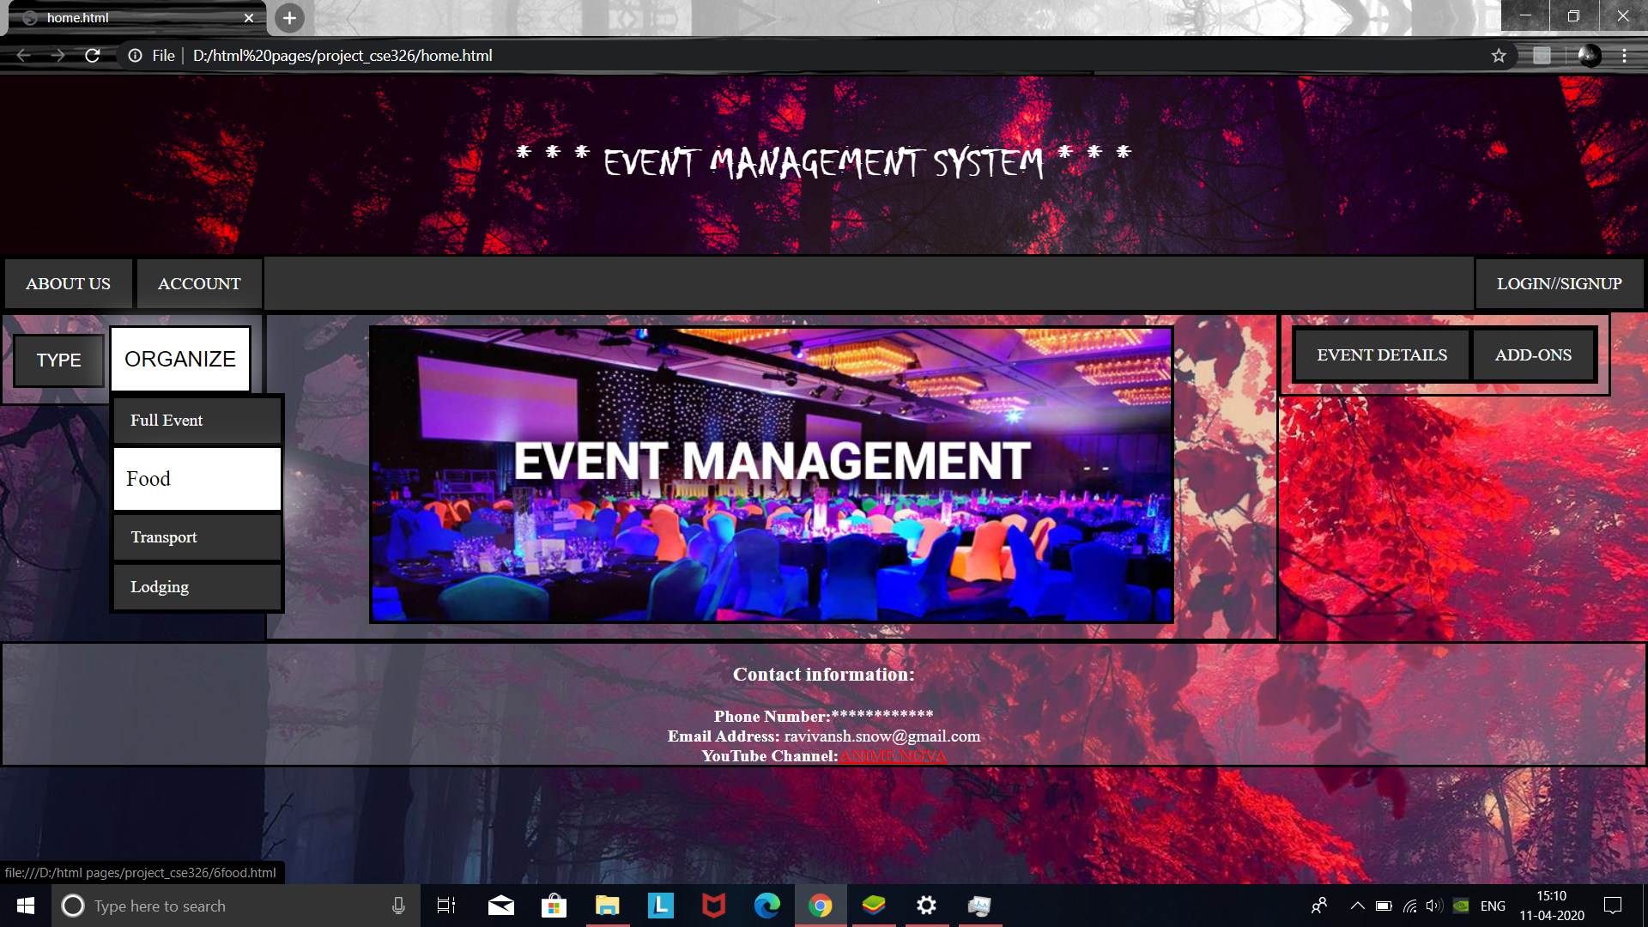

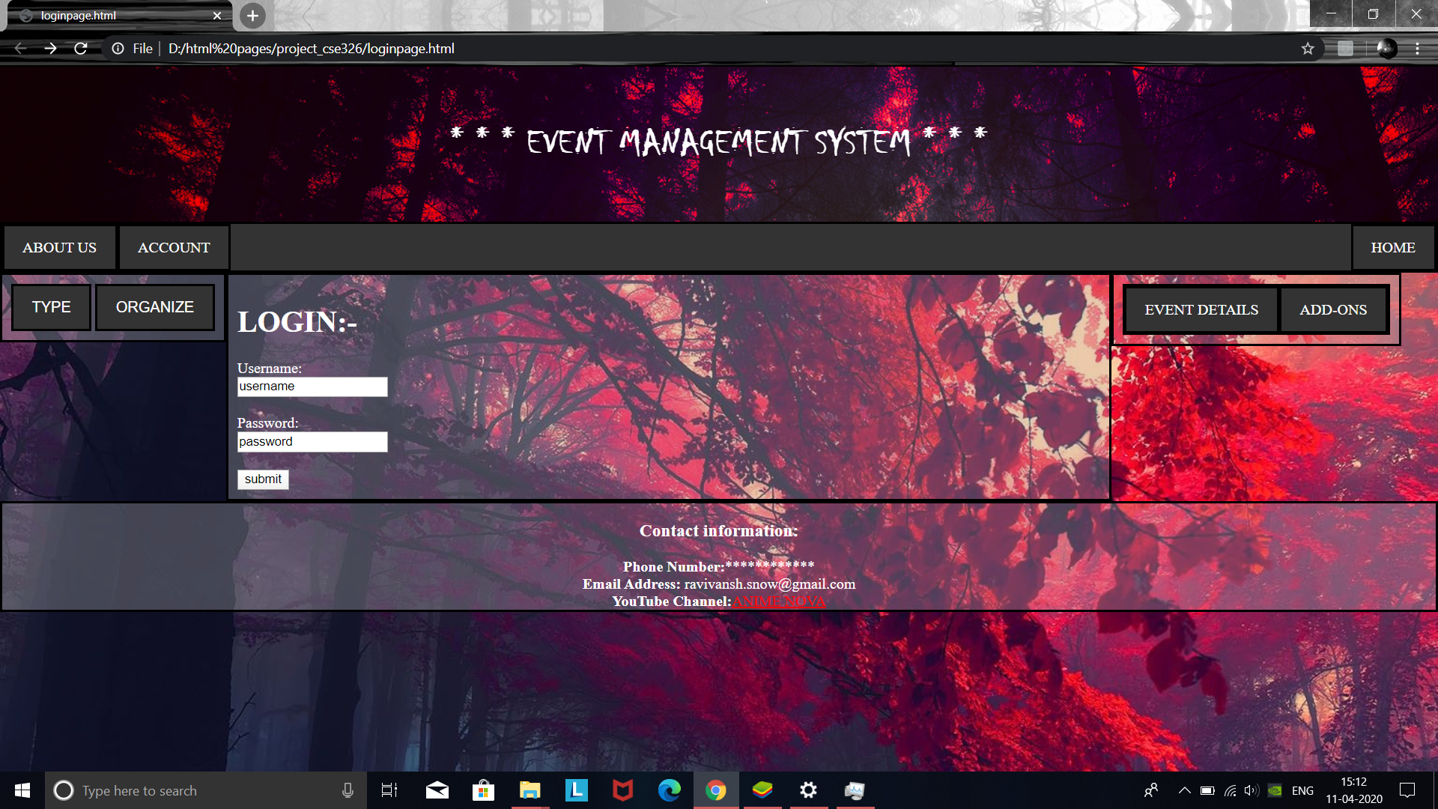

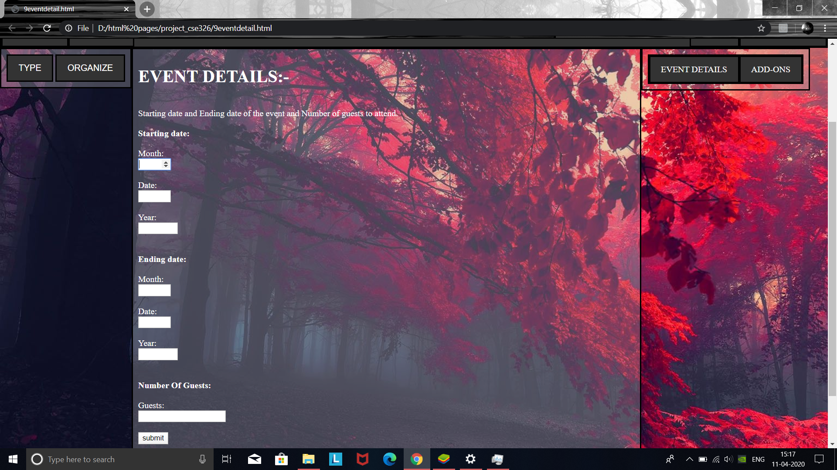

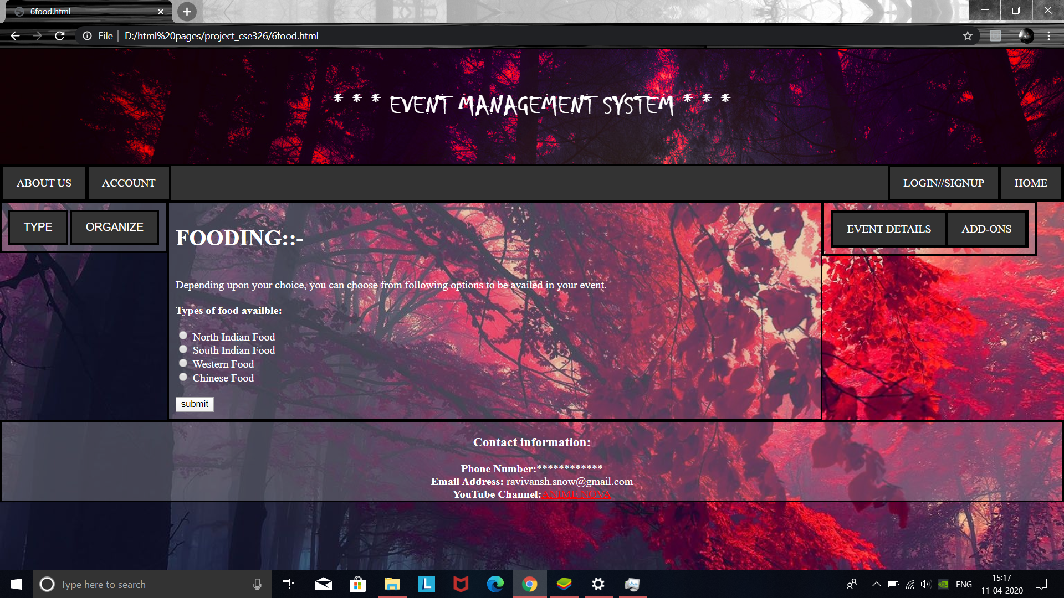

***MEDULE WORK/CREATION DISTRIBUTION:***

***MODULE NAME:***

* Home page
* About us page
* Account page
* Login / sign up page

***CREATED BY:***

***ABHAY PRATAP SINGH***

***MODULE NAME:***

* Full event page
* Food page
* Transport page
* Lodging page

***CREATED BY:***

***VIBHAV SINGH***

***MODULE NAME:***

* Sports page
* Cultural page
* Convocation page
* Conference page

***CREATED BY:***

***DILEEP PAL***